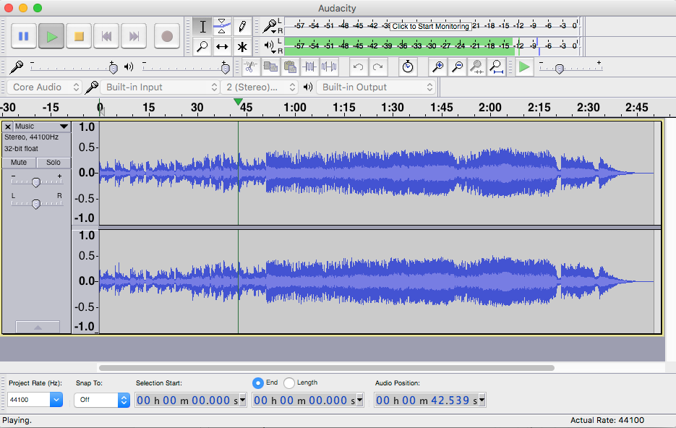

13

12

11

10

8

7

6
6
2

5
5
4

1
3

9

1. Pause button
2. Play button
3. Stop button
4. Skip to start and skip to end button
5. Start Recording
6. Tools section:
7. Playback level
8. Cut tool, Undo and redo, and zoom in and out
9. Track
10. Timeline
11. Input Slider bar
12. Output slider
13. Track Control panel

